Ex. No. : | 11 | Date : 05/10/2026
Register No. : | 240701491 | Name : PSharweshvar

Creating a Portal and Portal Users in Zoho Creator

Aim
To create a tenant portal for the RentEase application, to give portal users limited access with the Tenant_Profile permission set, to invite a tenant as a portal user, and to verify that the tenant can sign in and raise a maintenance request.

Introduction

Portals in Zoho Creator
A portal gives people outside the organisation, such as customers, tenants or vendors, access to a part of an application. A portal user signs in with his own account and sees only the forms and reports that his permission set allows. This keeps the internal data private while letting outside users do their own work. The steps in building a portal are to create the portal, define the permission set for its users, invite the users and test the sign-in.

The Tenant Portal of RentEase
In RentEase, tenants do not need the whole application. A tenant needs to see his lease, his invoices and his payments, and to raise a repair request or a move-out request. RentEase has one portal, and it is for tenants only. The manager and the owner are internal users and do not use the portal. The tenant Rahul Verma was invited to the portal and used it to raise a maintenance request.

Objectives of the Study
- To create a portal for the tenants of RentEase.
- To define the Tenant_Profile permission set and make it the default for portal users.
- To invite a tenant as a portal user.
- To sign in as the tenant and raise a maintenance request.
- To check that the request reaches the manager's side of the application.

Procedure
- Open the RentEase application in Edit mode and open the Portal section.
- Create a portal named RentEase and set its type to Public.
- Open Settings > Portal User Permissions and create the permission set Tenant_Profile. Give Access and View to the Lease_Agreement, Rent_Invoice, Rent_Payment, Maintenance_Request and Move_Out_Request reports and no other rights.
- Set Tenant_Profile as the default permission set of the portal.
- Open the portal users list and invite the tenant Rahul Verma with his email address.
- Open the invitation email as the tenant, accept it and set a password.
- Sign in at the portal URL as Rahul Verma and check the forms and reports that appear.
- Open the Maintenance_Request form in the portal, fill it and submit it.
- Sign in as the admin and check that the new request appears in the Maintenance_Request report.
1

Dept. of Computer Science and Engineering | Rajalakshmi Engineering College

- Take a screenshot of each step.

Detailed Analysis of the Portal
Table 1 lists the settings of the RentEase portal.

Item | Setting
Portal name | RentEase
Portal type | Public
Users of the portal | Tenants only
Permission set | Tenant_Profile
Default permission set | Tenant_Profile
Invited portal user | Rahul Verma
Table 1: Settings of the RentEase portal
Table 2 follows the portal from set-up to the first request of the tenant.

Step | Done by | Action | Result
1 | Admin | Creates the RentEase portal | A portal for tenants exists
2 | Admin | Defines the Tenant_Profile permission set | Tenants are limited to five forms and their reports
3 | Admin | Invites Rahul Verma | An invitation email is sent to the tenant
4 | Tenant | Accepts the invitation and signs in at the portal URL | The tenant sees the portal
5 | Tenant | Opens the Maintenance_Request form and submits it | A repair request is created
6 | Admin | Opens the Maintenance_Request report | The request is visible to the manager's side
Table 2: From portal set-up to the tenant's first request
Table 3 shows what the Tenant_Profile permission set gives to a portal user.

Component | Access | View (report) | Edit | Delete
Lease_Agreement | Yes | Lease_Agreement Report | No | No
Rent_Invoice | Yes | Rent_Invoice Report | No | No
Rent_Payment | Yes | Rent_Payment Report | No | No
Maintenance_Request | Yes | Maintenance_Request Report | No | No
Move_Out_Request | Yes | Move_Out_Request Report | No | No
Property, Unit, Tenant, Vendor, Repair_Approval, Command Center | No | - | No | No
Table 3: Access given by the Tenant_Profile permission set
During testing, the tenant reports in the portal showed No Data Available. This was not a fault of the portal or the permission set. The sample leases, invoices and payments had been created by the admin, and a tenant sees only the records that belong to him. Records created by or shared with the tenant appear in the portal.

2 Dept. of Computer Science and Engineering | Rajalakshmi Engineering College

Output
3
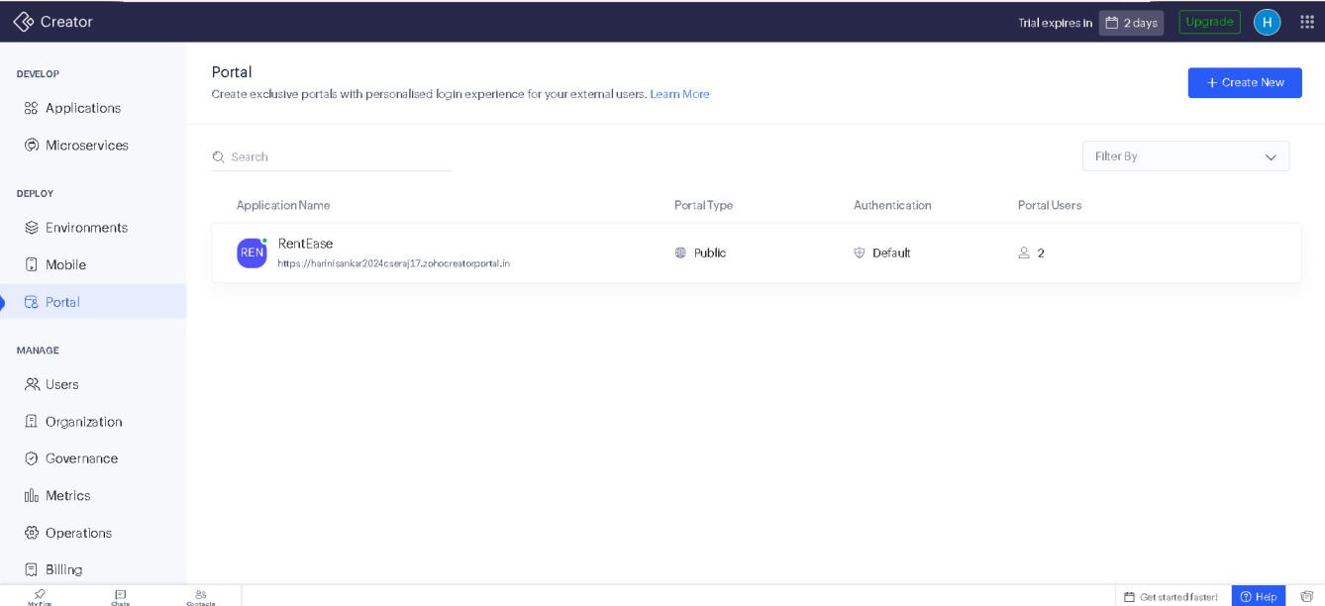
Figure 1: RentEase portal settings
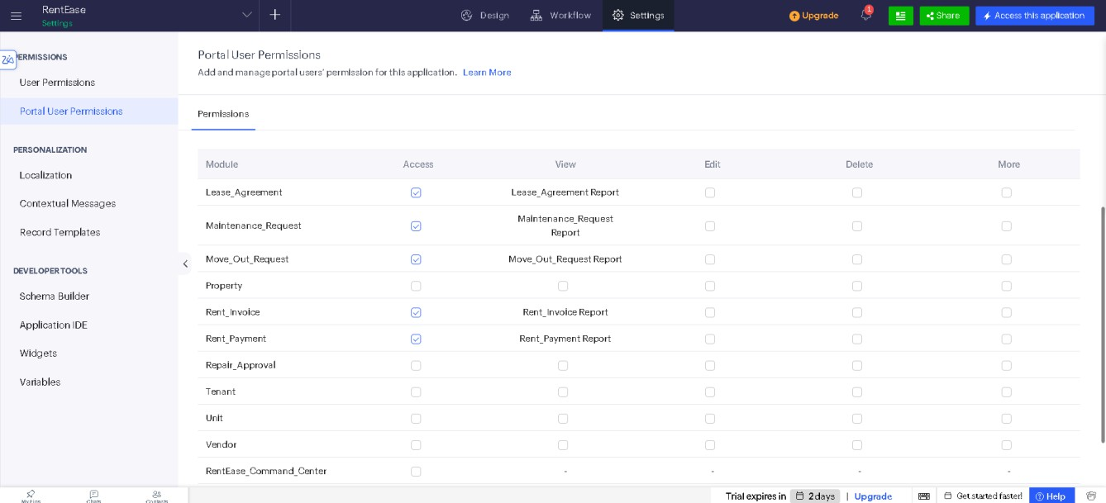
Figure 2: Tenant_Profile permission set

Dept. of Computer Science and Engineering | Rajalakshmi Engineering College

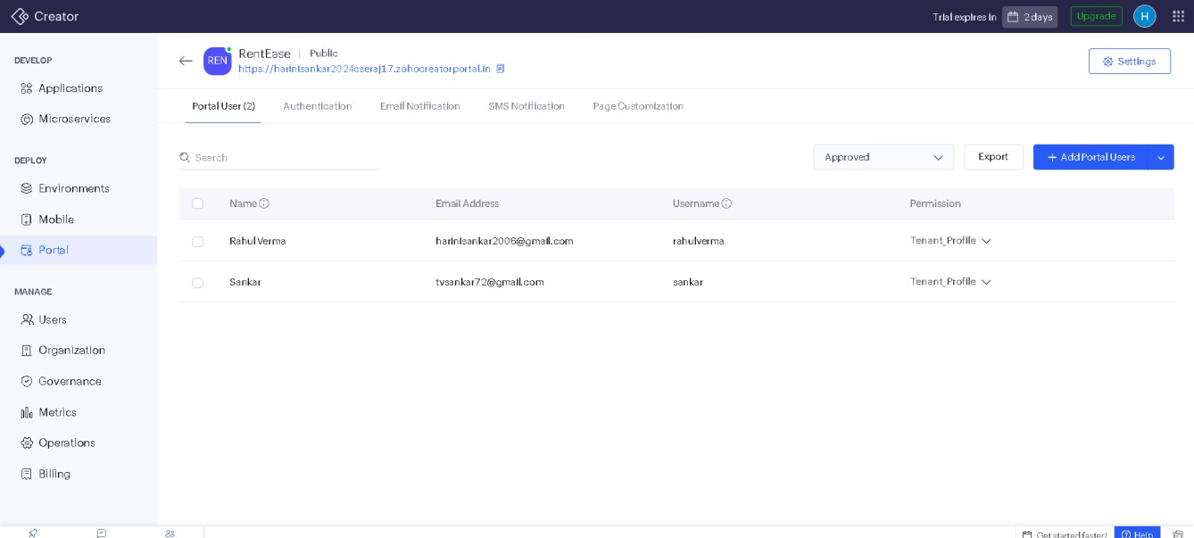
4
Figure 3: Tenant invited as a portal user
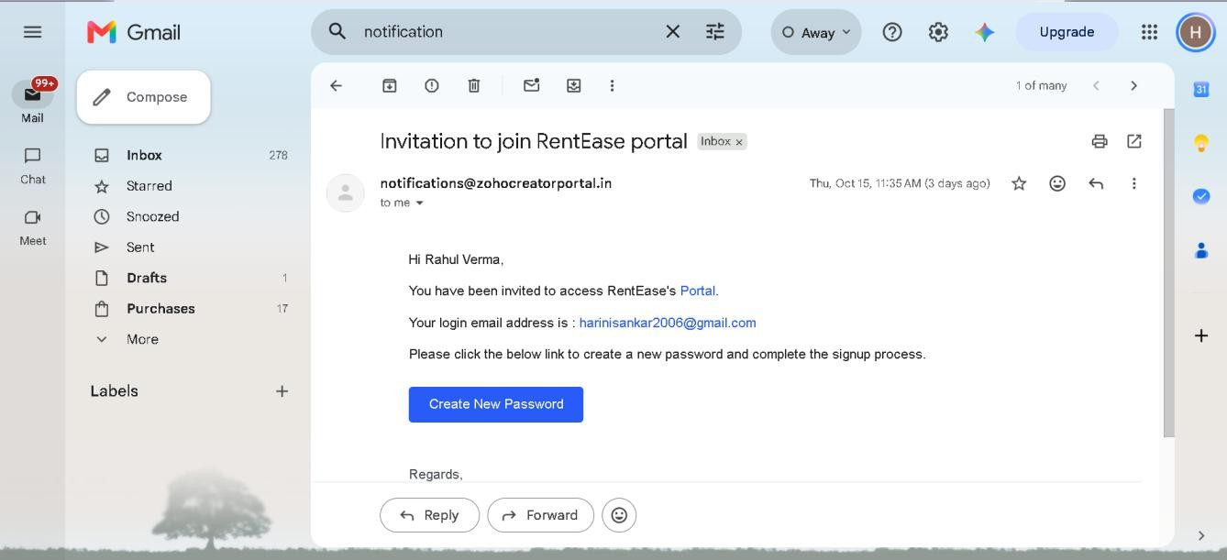
Figure 4: Invitation email

Dept. of Computer Science and Engineering | Rajalakshmi Engineering College

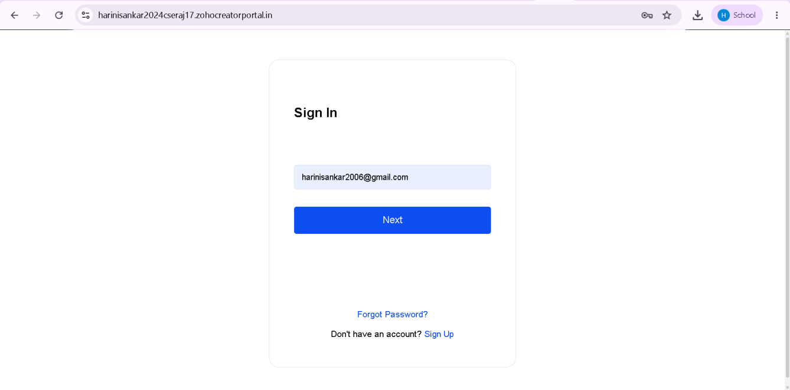
5
Figure 5: Tenant signing in to the portal
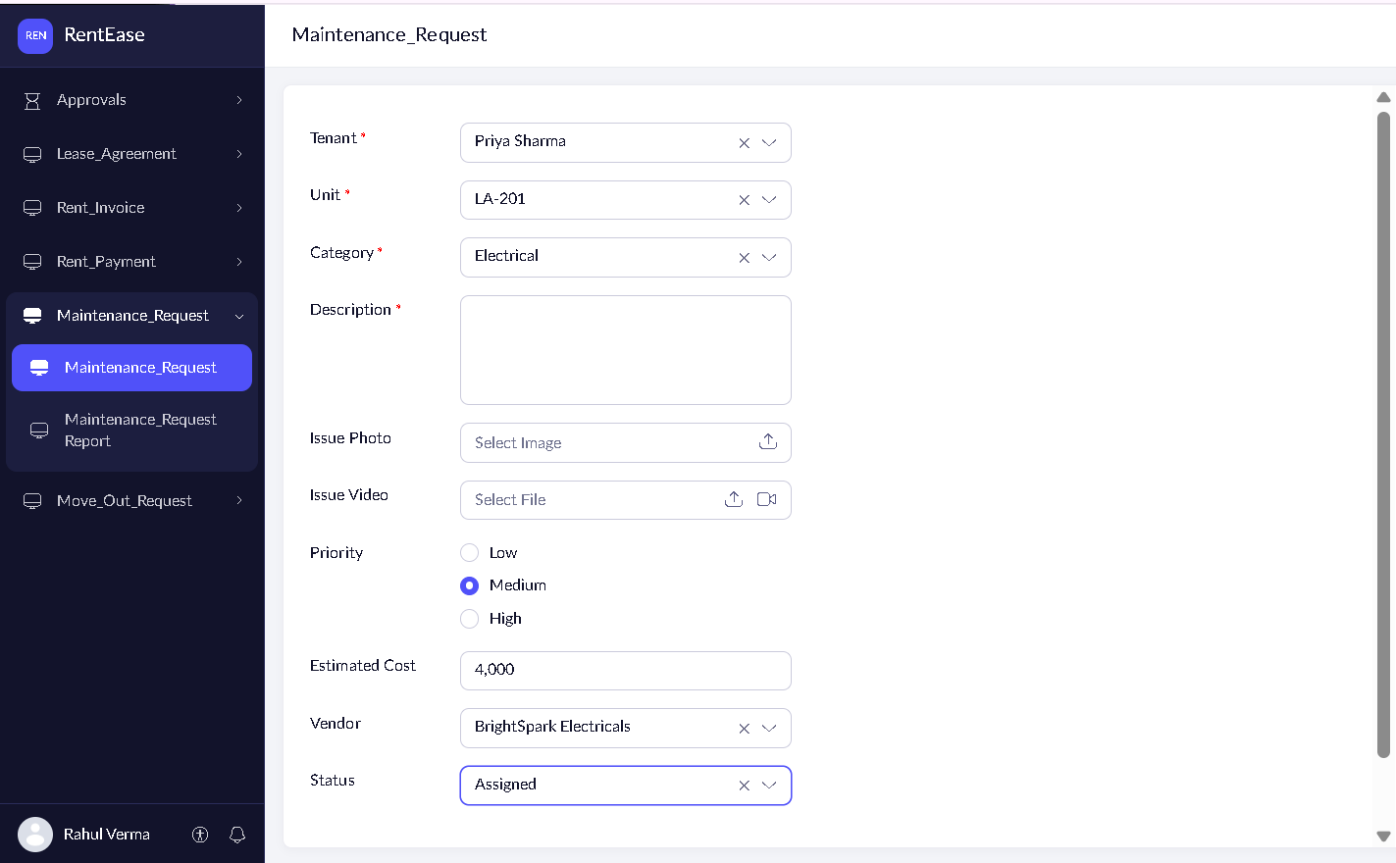
Figure 6: Tenant raising a maintenance request

Dept. of Computer Science and Engineering | Rajalakshmi Engineering College

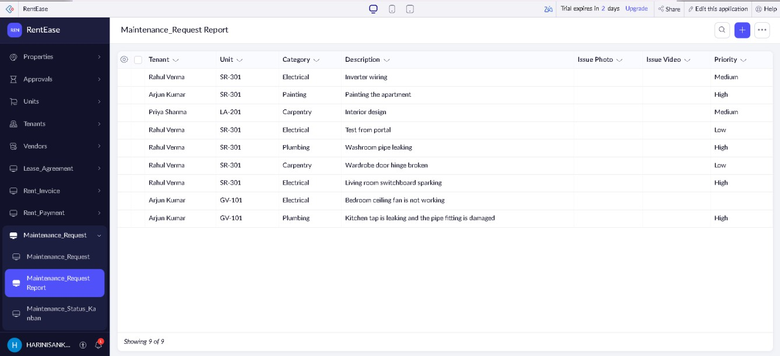
Figure 7: Tenant's request visible to the admin

Result
The RentEase portal was created for tenants, and the Tenant_Profile permission set was made its default. The tenant Rahul Verma was invited, signed in at the portal URL and raised a maintenance request, which then appeared in the application on the manager's side. The portal shows a tenant only the lease, invoice, payment, maintenance and move-out information that his permission set allows, without giving access to the rest of the application.
6

Dept. of Computer Science and Engineering | Rajalakshmi Engineering College

